Employee Guide


Table of Contents

Employee Guide I
Employee Guide: Login, Data Inquiries, Self Service & Leave Requests 1
Before You Begin 1
- Log on to EmployeePortal, Create an Account, & Manage Passwords 1
- Perform Employee Data Inquiries 9
- Perform Self Service Updates 13
- View Leave Balances & Manage Leave Requests 15

Employee Guide: Login, Data Inquiries, Self Service & Leave Requests

Welcome to ASCENDER EmployeePortal. This site provides you with access to various employee data inquiries and maintenance features.

EmployeePortal allows you to view your current and historical pay information including calendar year-to-date information, deductions, earnings, leave balances, W-2 information, and 1095 information. You can view up to 18 months of check stub information; year-to-date leave earned, leave used, and leave balances (including any unprocessed leave transactions entered for future payrolls).

In addition, you can create, edit, delete, and submit leave requests. EmployeePortal also oﬀers self- service maintenance pages that allow you to view and submit changes to your demographic and payroll information such as changes to your address, withholding and exemption status, and direct deposit settings. Some changes may require additional approval or documentation, which is predetermined by your LEA.

Your local education agency (LEA) determines the level of access you have in EmployeePortal. This allows them to hide certain pages or ﬁelds on a page. If you have questions about your level of access, contact your EmployeePortal administrator.

Before You Begin
Review the ASCENDER EmployeePortal Navigation page to familiarize yourself with the portal.

Log on to EmployeePortal, Create an Account, & Manage Passwords
To access the ASCENDER EmployeePortal, you must log on.

If you are a new user and do not have an ASCENDER EmployeePortal account, you must create an account.
  - Log in as a new user.

ASCENDER EmployeePortal > New User

If you are a new user, access the EmployeePortal link provided by your LEA. When you access EmployeePortal, the Login page is displayed.

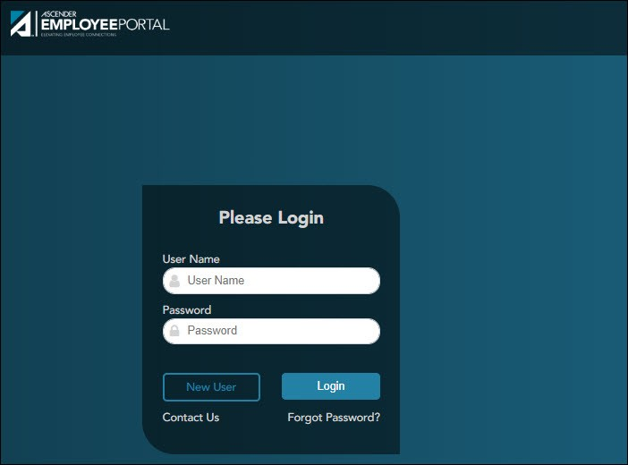

❏ Click New User. The New User page is displayed.

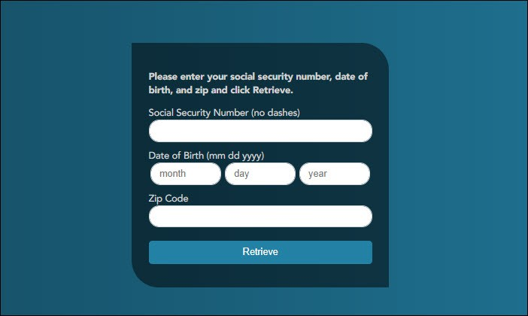

Employee Number or Social Security Number | Depending on your LEA's settings, you are prompted to enter either your employee number or your nine-digit social security number.
Date of Birth | Type your birth date in the mm dd yyyy format.
Zip Code | Type your ﬁve-digit zip code.

❏ Click Retrieve.

The entered data is veriﬁed to ensure that you are authorized to use EmployeePortal.
If you already created an account, a message is displayed prompting you to contact your personnel department.
The Employee Number or Social Security Number, Date of Birth, Zip Code, Last Name, and First Name ﬁelds cannot be modiﬁed.

❏ Enter the following information:

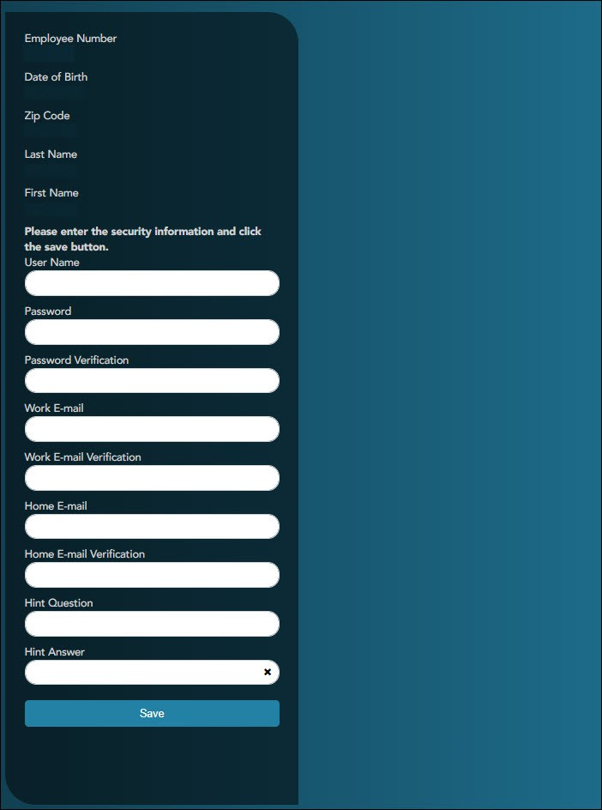

User Name | Type a six-to-eight character user name. (No embedded spaces are allowed.) The name must be unique within the LEA; it is not case- sensitive.
Password | Type a new six-to-nine alphanumeric password. The password must contain at least one uppercase letter, one lowercase letter, and one number.

Password Veriﬁcation | Retype the six-to-nine character password that you typed in the  Password ﬁeld.
Work E-mail | Type the work email address if it does not display. If a work email address already exists, this ﬁeld cannot be modiﬁed.
Work E-mail Veriﬁcation | Retype the work email address that you typed in the Work E-mail ﬁeld (if available for modiﬁcation).
Home E-mail | Type the home email address if it does not display. If a home email address already exists, this ﬁeld cannot be modiﬁed.
Home E-mail Veriﬁcation | Retype the home email address that you typed in the Home E-mail  ﬁeld (if available for modiﬁcation).
Hint Question | Type a question you will be asked in the event that you forget your password at a later date.
Hint Answer | Type the answer to the hint question. This is case-sensitive.

❏ Click Save. The EmployeePortal home page is displayed indicating that you have successfully logged on to the portal. You will receive a conﬁrmation email message containing your user name.

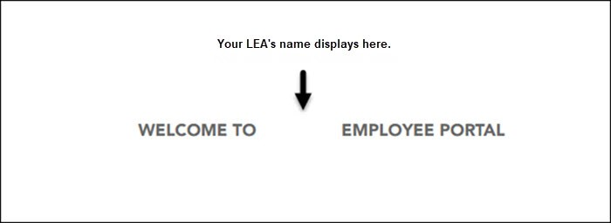



  - Log in as an existing user.

ASCENDER EmployeePortal > Login

If you are an existing user, access the EmployeePortal link provided by your LEA. When you access EmployeePortal, the Login page is displayed.
IMPORTANT: If you are an existing TxEIS Employee Access user, log on using your same user name and password.

❏ Enter the following information:

User Name | Type the user name you entered when you created your ASCENDER EmployeePortal account. Your user name is not case-sensitive.
Password | Type the most recent password entered for this account. Your password is case- sensitive.

❏ Click Login. The EmployeePortal home page is displayed.

WARNING! If you have three unsuccessful attempts to log on (invalid user name/password combinations), the system will lock out your account for 5 minutes. Try logging on again after 5 minutes.

  - Change your password.

ASCENDER EmployeePortal > Change Password

This page is used to change your current password. If you forgot your password, use the Forgot Password page to reset your password. If you are locked out of your account, contact your LEA's EmployeePortal administrator.

Access the EmployeePortal link provided by your LEA. When you access EmployeePortal, the Login page is displayed. After you have successfully logged on to the portal, the EmployeePortal home page is displayed. Click your name in the upper-left corner or click at any time to access the Self-Service Proﬁle page.

❏ Click Change Password. The Change Password window opens.

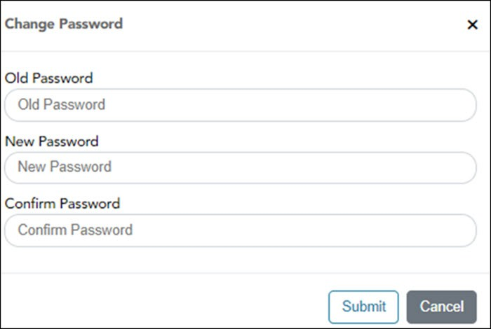

Old Password | Type your current EmployeePortal password.
New Password | Type a six-to-nine alphanumeric password. The password must contain at least one uppercase letter, one lowercase letter, and one number.
Conﬁrm Password | Retype the six-to-nine alphanumeric password that you typed in the New Password ﬁeld.

❏ Click Submit to update your current password to the new password. Otherwise, click Cancel to close the window without saving any changes. You will receive a conﬁrmation email message notifying you that your password changed.

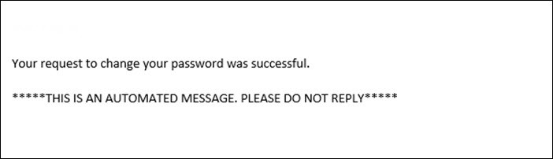

  - Recover your password.

ASCENDER EmployeePortal > Forgot Password

This page is used to reset your password if you forgot it. If you are an existing user and you know your current password and want to change it, use the Change Password page. If you are locked out of your account, contact your EmployeePortal administrator.

❏ From the EmployeePortal home page, click Forgot Password. The Forgot Password page is displayed.
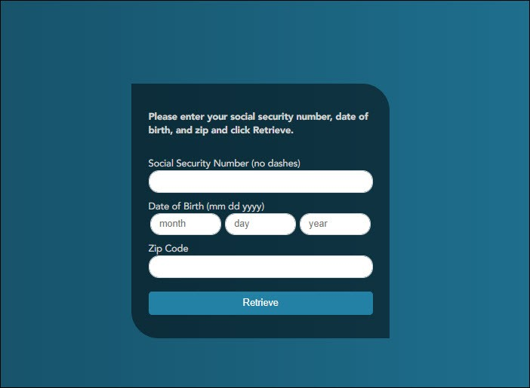

Employee Number or Social Security Number | Depending on your LEA's settings, you are prompted for either your employee number or your nine-digit social security number.
Date of Birth | Type your birth date in the MMDDYYYY format.
Zip Code | Type your ﬁve-digit zip code.

❏ Click Retrieve.

The entered data is veriﬁed to ensure that you are authorized to use EmployeePortal. The Employee Number or Social Security Number, Date of Birth, Zip Code, Last Name, and First Name ﬁelds cannot be modiﬁed.

❏ You are prompted to answer the hint question that you entered when you created your user account.

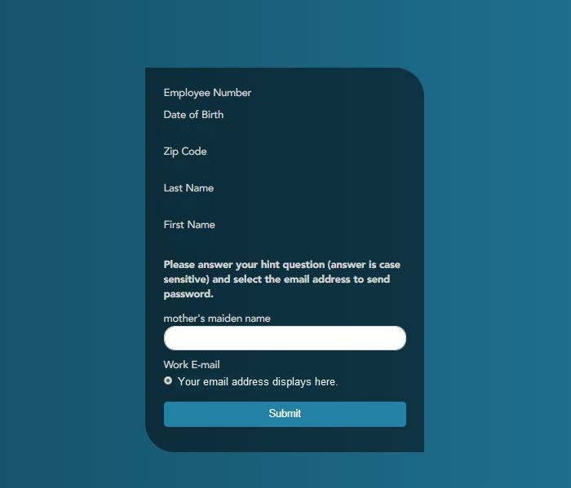

In the hint answer ﬁeld, type the answer to the hint question. You have three opportunities to answer the question correctly.
If the question is not correctly answered, the answer is protected, and you are prompted to call your EmployeePortal administrator to have your user account deleted. Once your user account is deleted, you can use the New User page to create your account again.

❏ Click Submit. You are redirected to the EmployeePortal Login page. An email message containing your temporary password is sent to your email address.

❏ Obtain your temporary password from your email and return to the EmployeePortal Login page. The temporary password is only valid for 24 hours.

❏ Type your user name and the temporary password and click Login. You are redirected to the Change Password page. Follow the instructions for changing your password.

Perform Employee Data Inquiries

Use the Inquiry menu to perform various inquires on payroll, leave, and tax information. The following
data inquiries are available. Review the applicable online Help pages for information about speciﬁc ﬁelds.

  - Calendar Year to Date.

EmployeePortal > Inquiry > Calendar Year to Date

This page is used to view a year-to-date summary of various earnings information by payroll frequency. You can also view prior year information.

If this page is not enabled, check with your EmployeePortal administrator, as the district may have opted to not allow access.

If a district-wide message is available, it is displayed in red at the top of the page.

  - Current Pay Information.

EmployeePortal > Inquiry > Current Pay Information

This page is used to view your current pay information.

If you requested modiﬁcations such as changes to your withholding and exemptions, and those changes are not displayed, the district has yet to process the changes.

If this page is not enabled, check with your EmployeePortal administrator, as the district may have opted to not allow access.

If a district-wide message is available, it is displayed in red at the top of the page.

  - Deductions.

EmployeePortal > Inquiry > Deductions

This page is used to view your current payroll deduction information. If applicable, the employer's contributions to the deductions are also displayed in addition to your withholding status and the number of exemptions.

If you have requested modiﬁcations to your deductions and those changes are not displayed, the district has yet to process the changes.

If this page is not enabled, check with your EmployeePortal administrator, as the district may have opted to not allow access.

If a district-wide message is available, it is displayed in red at the top of the page.
  - Earnings.

EmployeePortal > Inquiry > Earnings

This page is used to view earnings and direct deposit information. The information is per pay date and frequency. You can view 18 months of earnings or the last 50 pay dates. If you are on multiple frequencies, the pay dates and associated frequency are displayed.

If this page is not enabled, check with your EmployeePortal administrator, as the district may have opted to not allow access.

If a district-wide message is available, it is displayed in red at the top of the page.

  - W-2 Information.

EmployeePortal > Inquiry > W-2 Information

This page is used to view your W-2 information. Additionally, you can indicate how you want to receive and access your W-2 form; electronically or printed, by mail. Previous year and frequency combinations are available for selection. Oﬃcial W-2s can be printed from calendar year 2009 or greater. W-2s from years prior to 2009 can be viewed but not printed.

If this page is not enabled, check with your EmployeePortal administrator, as the district may have opted to not allow access.

If a district-wide message is available, it is displayed in red at the top of the page.

In addition, you can use this page to indicate your W-2 electronic consent preference. If you have not previously provided your electronic consent preference, the W-2 Electronic Consent window opens when you access the W-2 Information page. You can change your electronic consent preference at any time.

❏ Click W-2 Consent. The W-2 Electronic Consent window opens with information about your consent.

The W-2 Consent button is only displayed if the option is enabled by the LEA or service center.

Select Yes if you consent to electronic access of your W-2 form and agree to access your W-2 form electronically as described in the instructions, and print your own W-2 form. If selected, you will not receive a printed, mailed copy of your W-2 form.
Select No to decline electronic consent and receive a printed, mailed copy of your W-2 form.
Click Save to save your consent election. Otherwise, click Cancel to close the window without making a selection. If you do not make a selection, your W-2 form will be printed and mailed.

Notes:

You can print a copy of your W-2 form regardless of your selected consent preference.
You can change your consent preference at any time.
You will receive an email message conﬁrming your selected preference.
The conﬁrmation email is sent to the email address listed on your demographic record in Human Resources. The email is sent to either the work or home email address; whichever is available. If both are available, the email is sent to the work email address.

❏ Click to display a printable PDF version of your Form W-2 Wage and Tax Statement.
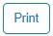

  - 1095 Information.

EmployeePortal > Inquiry > 1095 Information

This page is used to view your 1095 information. Additionally, you can indicate how you would like to receive and access your 1095 form; electronically or printed, by mail. Oﬃcial 1095 forms can be printed and viewed from calendar year 2015 and greater.

If this page is not enabled, check with your EmployeePortal administrator, as the district may have opted to not allow access.

If a district-wide message is available, it is displayed in red at the top of the page.

❏ Select 1095-B to display your 1095-B data for the selected calendar year. OR
❏ Select 1095-C to display your 1095-C data for the selected calendar year.

In addition, you can use this page to indicate your 1095 electronic consent preference. If you have not previously provided your electronic consent preference, the 1095 Electronic Consent window opens when you access the 1095 Information page. You can change your electronic consent preference at any time.
❏ Click 1095 Consent. The 1095 Electronic Consent window opens with information about your consent.

The 1095 Consent button is only displayed if the option is enabled by the district or service center.

Select Yes if you consent to electronic access of your 1095 form and agree to access your 1095 form electronically as described in the instructions, and print your own 1095 form. If selected, you will not receive a printed, mailed copy of your 1095 form.
Select No to decline electronic consent and receive a printed, mailed copy of your 1095 form.
Click Save to save your consent election. Otherwise, click Cancel to close the window without making a selection. If you do not make a selection, your 1095 form will be printed and mailed.

Notes:

You can print a copy of your 1095 form regardless of your selected consent preference.
You can change your consent preference at any time.
You will receive an email message conﬁrming your selected preference.
The conﬁrmation email is sent to the email address listed on your demographic record in Human Resources. The email is sent to either the work or home email address; whichever is available. If both are available, the email is sent to the work email address.

❏ Click to display a printable PDF version of the Form 1095-B or 1095-C.

Perform Self Service Updates (if service has been enabled)

Use the Employee Self Service page to submit changes to your personal demographic and payroll information. All submitted changes are considered “pending” until approved by your LEA. Review the online Help page for information about speciﬁc ﬁelds.

  - Update demographic and payroll information.

ASCENDER EmployeePortal > Self-Service

This page is used to enter and request updates to your demographic and payroll information. Your information as it currently exists in your record is displayed.

Click your name in the upper-left corner or click
Proﬁle page.
at any time to access the Self-Service

❏ The ﬁelds that you are allowed to view and update are determined by your LEA. Your submitted changes may go through an approval process.

❏ Your current information is displayed in the Current and New columns.

The Current column is display only.
The New column is only enabled if the LEA allows updates to the data. If the New column ﬁelds are enabled, you can enter your changes and click Save. The data is saved and submitted for approval.
Pending requests are highlighted yellow after the changes are submitted. If approval is not required, the changes are made immediately. If the requests are pending approval, you can continue to change your request until it has been approved and updated in the system.
Click Undo to revert the data to its original state. A message is displayed conﬁrming that you want to cancel your changes.
Click OK to cancel your requested changes.
Otherwise, click Cancel to close the message without changing your request.
If the ﬁelds are not automatically updated, an email message is sent to the applicable approver prompting them to approve the submitted changes.
You will receive an automatic reply email containing the changes and informing you that the changes are pending approval.

❏ To delete information, delete the data in the New column and click Save.

❏ If a change is made more than once for the same ﬁeld, the most recent change overrides the previous one.

❏ Some ﬁelds may require you to submit documentation to your employer. If documentation is required, the ﬁelds are identiﬁed in the automatic reply email message.

Payroll:

Under W4 Marital Status Information:

❏ To delete information, delete the data in the New column and click Update.

❏ Click Undo to return the data to its original state. A message is displayed conﬁrming that you want to cancel your changes.

Under Direct Deposit Bank Accounts:

❏ Click Add to add a new ﬁnancial institution to have your paycheck directly deposited.

❏ Click Delete to delete a ﬁnancial institution from your record.

❏ To delete information, delete the data in the New column and click Update.
❏ Click Undo to return the data to its original state. A message is displayed conﬁrming that you want to cancel your changes.

View Leave Balances & Manage Leave Requests

  - View leave balances.

ASCENDER EmployeePortal > Leave Balances

This page is used to view leave information as it currently exists in your record for the selected frequency.

If this page is not enabled, check with your EmployeePortal administrator, as the district may have opted to not allow access.

If a message is available from your LEA, it is displayed in red at the top of the page.

View leave balance data:
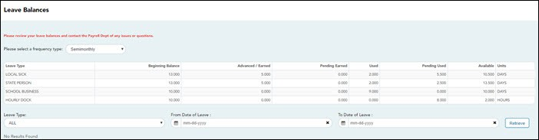

Leave Type | The speciﬁc leave code(s) for which you have leave data is displayed. The leave types are ﬁrst displayed in the order that is set for your check (called stub position), and then leave type code (01-99) order.
Beginning Balance | The leave balance as of the beginning of this year for each leave type is displayed.
Advanced/Earned | The number of units of leave advanced or earned as of the last pay period is displayed.
Pending Earned | The total leave earned but not yet processed through payroll is displayed.
Used | The number of units of leave used as of the last pay period is displayed.
Pending Used | The total leave pending and approved but not yet processed through payroll is displayed. This amount is subtracted from the Available Balance ﬁeld.
Available | The total number of leave units still available for use is displayed. The Available balance is determined by the following calculation: (prior year balance + advanced earned + pending earned) - used - pending used

Units | Indicates the type of units (hours or days) that is used when calculating leave requests.

View a speciﬁc range of leave data:
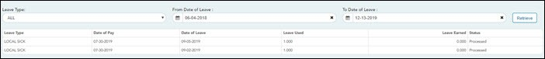

❏ Use the following ﬁelds to ﬁlter the information by date range and/or leave type.

Leave Type | Click to select the type of leave for which you want to view leave data. The leave type description is displayed.
From and To Date of Leave | Type the range of dates for which you want to view processed and unprocessed leave data or click to select the dates.  - The from date may not exceed 18 months from the current date.  - You can leave the date ﬁelds blank to retrieve dates 18 months from the current date.  Note: The from and to date selections select leave dates rather than pay dates. Additionally, if the from and to dates are left blank, all future leave and all prior leave up to 18 months is retrieved. If a from date is entered and no to date is entered, all leave starting with the from date and all future leave is retrieved.

❏ Click Retrieve. A list of leave requests for the speciﬁed date range is displayed with the following data:

Leave Type | The leave type description for the leave request is displayed.
Date of Pay | The pay date for which leave was charged is displayed.
Date of Leave | The date for which the leave was taken is displayed in the mm dd yyyy format.
Leave Used | The number of units of leave taken is displayed.
Leave Earned | The number of units of leave earned is displayed.
Status | Indicates the status of the leave (processed, not processed, or not posted to payroll). The data displayed here depends on certain district option settings. For example, if you know you have leave that has not gone through payroll processing, then the feature to display unprocessed leave was disabled by the district.  - Processed - The leave has been processed through payroll and posted to your leave master record.  - Not processed - The leave has not been processed through payroll and is not yet a part of your leave master record.  - Processed and not processed leave units have already been added to/subtracted (as appropriate) from your master leave record and are reﬂected in the leave grid.  - The Available ﬁeld is reﬂective of what is available should all unprocessed leave be posted.

  - Create, edit, and delete leave requests.

ASCENDER EmployeePortal > Leave Requests

This page is used to create, edit, delete, and submit leave requests for the selected payroll frequency. After a leave request is processed by payroll, it is no longer displayed on this page.

If this page is not enabled, check with your EmployeePortal administrator, as the district may have opted to not allow access.

If a message is available from your LEA, it is displayed in red at the top of the page.

Payroll Frequency
Clickto select the payroll frequency for which you want to create a leave request. If you have leave in multiple payroll frequencies such as biweekly, semimonthly, and monthly, those options are displayed and can be selected.
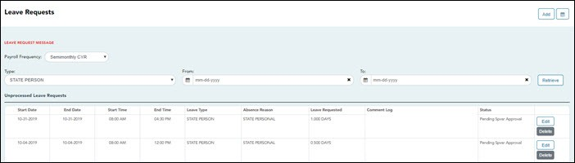

Under Unprocessed Leave Requests, a list of your unprocessed (not processed by payroll) leave requests is displayed, if any. The following details are displayed for each leave request:

Start and End Date | The start and end date range for the leave request is displayed in the MMDDYYYY format.
Start and End Time | The start and end time range for the leave request is displayed in the HH MM format.
Leave Type | The type of requested leave is displayed.
Comment Log | Any employee (requestor) comments that were added to the leave request are displayed.

Status
The current status of the leave request is displayed.

When a leave request is created, an email message is automatically sent to your direct supervisor notifying him of the request and prompting him to approve or disapprove the leave request. The status of the leave request is updated to Pending Spvsr Approval.

After a leave request is approved by your supervisor, an email message is automatically sent to the email address listed on your Human Resources demographic record notifying you of the action. The status of the leave request is updated to Pending Payroll.

If a leave request is disapproved by your supervisor, an email message is automatically sent to the email address listed on your Human Resources demographic record notifying you of the action. The status of the leave request is updated to Disapproved. You can edit and resubmit the leave request or delete the leave request.

After a leave request is processed by payroll, it is no longer displayed on this page.

Create a leave request:

❏ You have two options to create a leave request.

    - Click Add in the upper-right corner of the page. The Create Leave Requests window opens.
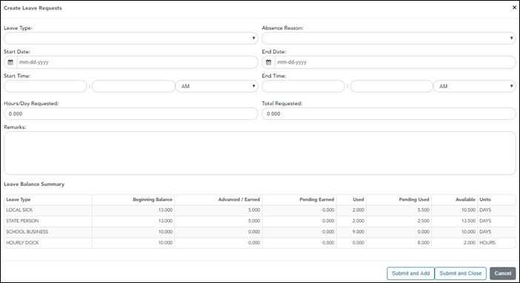

1. Click . A view of the current month calendar is displayed. You can click an existing leave request from the calendar to view the details.

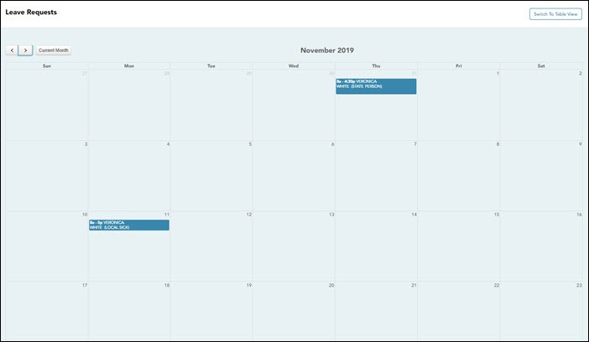

Click the calendar day for which you want to create a leave request. The Create Leave Requests window opens. The Start Date and End Date ﬁelds are automatically populated with the date you selected.
Click to view the previous month. Click to view the next month.
Click Current Month to view the current month. The Current Month button is only enabled if you are viewing a prior or future month.
Click Switch to Table View to return to the table display.

Your leave balances are displayed at the bottom of the Create Leave Requests window.

❏ Complete the following information for the leave entry:

Leave Type | Click to select the type of leave that you want to request. Only leave types assigned to you are displayed. A district setting determines whether or not you can use a leave type with a zero balance.
Absence Reason | Click to select the absence reason. The absence reasons are determined by your district and correspond to the selected leave type.
Start Date | Type the start date for which you want to request leave in the MM/DD/YYYY format or click to select a date from the calendar.
End Date | This ﬁeld is automatically populated with the date selected in the Start Date ﬁeld; however, you can change the date. Type the end date for which you want to request leave in the MM/DD/YYYY format or click to select a date from the calendar. You can use this ﬁeld to cover consecutive dates of a leave request excluding the weekend (Saturday/Sunday).
Start Time | Type the beginning time in the HH MM format for which you want to request leave. Click to select AM or PM.
End Time | Type the end time in the HH MM format for which you want to request leave. Click to select AM or PM.

Hours/Day Requested | The number of hours per day for which you are requesting leave is automatically calculated based on the Start Time and End Time of the leave request.  If the ﬁeld is not automatically calculated, you must manually type the number of hours per day for which you are requesting leave. A district setting determines whether or not this ﬁeld is automatically calculated.
Total Requested | The total amount of requested hours or days for the leave request is displayed. The calculation is based on the selected leave type units.  - If the leave type unit is set to Hours, the total requested amount is calculated in hours based on the start and end time of the leave request. For example, if you create a leave request with a start date of 02/23 and an end date of 2/24 for two hours, then the Hours/Day Requested column displays  2.000 hours and the Total Requested column displays 4.000 hours indicating that you requested a total of four hours; two hours of leave per day.  - If the leave type unit is set to Days, the total requested amount is calculated in days based on the start and end date of the leave request. For example, if you create a leave request with a start date of 02/23 and an end date of 2/24 for two hours, then the Hours/Day Requested column displays 2.000 hours indicating that you are requesting two hours per day. The Total Requested column displays the total percent of day requested based on the percent of day data that exists for the leave type on the Human Resources > Tables > Leave > Units tab.
Remarks | Type any comments related to your leave request. The comments are available to all approvers.

The leave balance amounts translate to hours or days based on the assigned unit type for the selected leave type.

Leave Type | The speciﬁc leave code(s) for which you have leave data is displayed. The leave types are ﬁrst displayed in the order that is set for your check (called stub position), and then leave type code (01-99) order.
Beginning Balance | The leave balance as of the beginning of this year for each leave type is displayed.
Advanced/Earned | The number of units of leave advanced or earned as of the last pay period is displayed.
Pending Earned | The total leave earned but not yet processed through payroll is displayed.
Used | The number of units of leave used as of the last pay period is displayed.
Pending Used | The total leave pending and approved but not yet processed through payroll is displayed. This amount is subtracted from the Available Balance ﬁeld.
Available | Indicates the number of units of leave still available for use. The Available is based on beginning balance, plus advanced/earned, plus pending earned, less used, and less pending used.
Units | Indicates the type of units (hours or days) that is used when calculating leave requests.

After completing your leave request entry, use one of the following options to continue:

❏ Click Submit and Add to submit the leave request to your supervisor for approval and remain on the Create Leave Requests window to continue adding additional leave request
entries.

❏ Click Submit and Close to submit the leave request to your supervisor for approval and close the Create Leave Requests window.

A leave request is created and an email message is sent to your direct supervisor notifying him that there is a leave request pending approval.
Depending on the leave type, additional approvers may be in the approval path for the leave request.
If you are set as the temporary approver for your supervisor, and you enter a leave request when your supervisor is unavailable, the request is submitted to your supervisor's supervisor. You are not allowed to approve your own leave requests. When a leave request is approved or disapproved, an email message is automatically sent to the email address listed on your Human Resources demographic record notifying you of the action.

❏ Click Cancel to close the Create Leave Requests window without submitting any leave requests and return to the Leave Requests page.

Edit a leave request:

❏ You can edit a leave request until it is processed by payroll in which case, the leave request is no longer displayed under Unprocessed Leave Requests.
Edit
Click Edit next to the leave request that you want to edit. The Edit Leave Requests window opens.
Make the necessary changes and click Resubmit for Approval to resubmit the edited leave request for approval. Otherwise, click Cancel to return to the Leave Requests page.

Delete a leave request:

❏ You can delete a leave request until it is processed by payroll in which case, the leave request is no longer displayed under Unprocessed Leave Requests.
Delete
Click Delete next to the leave request that you want to delete. A message prompting you to conﬁrm deletion is displayed.
Click OK to delete the leave request. Otherwise, click Cancel to return to the Leave Requests page.

